WORKSHEET A1.1

Object-Oriented Programming

The following object declarations and initializations will be used for all questions. This code will create a DrawingTool object called marker and a SketchPad object called poster. The poster will have dimensions of 600 x 600, and the marker will be constructed and used on the poster. Each drawing will begin at the center of the poster at the point (0,0).

DrawingTool marker;
SketchPad poster;

poster = new SketchPad(600,600);
marker = new DrawingTool(poster);

1. Draw the figure generated by the following code segment:

marker.forward(120);
marker.turnRight(45);
marker.forward(80);
marker.turnLeft(90);
marker.forward(80);
marker.turnLeft(90);
marker.forward(80);
marker.turnLeft(90);
marker.forward(80);

2. Draw lines A and B as described by the following – note the move() method is introduced here for line B. It allows you to draw lines with fewer commands:

marker.up();
marker.turnRight(90);
marker.forward(100);
marker.down();
marker.drawString(" A");
marker.move(-100,0);
marker.up();
marker.move(-175,100);
marker.down();
marker.move(175,100);
marker.drawString(" B");

3. Write code that will draw the following figure. The lower left corner is at the point (0,0), and the length of each side of the square is 200 units. The upper left part of the mouth begins at (40,60), and the upper part of the nose begins at (100,100). The eyes each have a radius of 10 units and are centered at (60,150) and (140,150). The other key points are left for you to decide. Have fun!
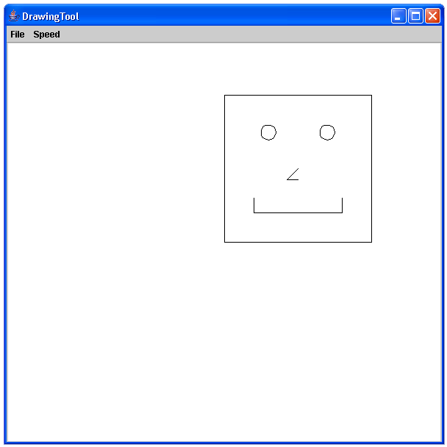

4. Enhance # 2 by writing code to connect the left endpoint of B to the right endpoint of A. Write additional code to connect the right endpoint of B to the left endpoint of A.

5. Enhance # 2 again by writing code to construct the perpendicular bisector to segments A and B (25 units above B and 25 units below A).

